BELMONT CITY COLLEGE

YEAR 11 ATAR MODERN HISTORY

SOURCE ANALYSIS – UNIT 1

SEMESTER ONE 2015

DOCUMENT BOOKLET

MODERN HISTORY SOURCE ANALYSIS

Date: Friday Week 10

Marks: 25 marks

12.5% of Semester Total

CONTENTS:

Document Set | Area of Study | Number of sources | Related questions
1 | Elective 5: The Age of Imperialism | 4 | 1 (5 parts)

DOCUMENT SET
THE AGE OF IMPERIALISM

Source 1

People waiting for famine relief in Bangalore (The famine the image depicts is the Great Famine of 1876–78)

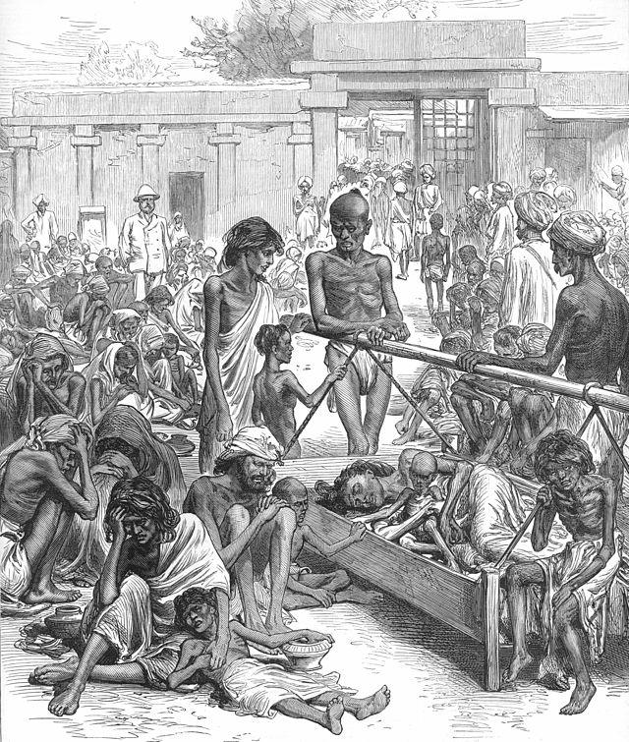

Source 2

Excerpts from a newspaper article in the Sydney Morning Herald in 1877 announcing the proclamation of Queen Victoria as Empress of India.

THE PROCLAMATION OF VICTORIA AS EMPRESS OF INDIA.
(From the Correspondent of the Times, of India)
Delhi, January 1- Today the Queen of England was proclaimed Empress of India. The history of India before newspapers were invented is somewhat dim in regard to the particulars of the great pageants which have often been held at the old capital of the Moguls, but it would be difficult for even an Oriental mind to imagine a scene of such grandeur and splendour as that witnessed from the Imperial dais this morning. It is doubtful whether any country of any age has ever known so magnificent a spectacle . . . Then came the Viceroy himself, wearing the star-bespangled sky blue mantle of a Grand Commander of the Star of India … The following is the substance of the Viceroy's address at the assemblage. His Excellency first referred to the Queen's proclamation of 1st November, l858, conveying to the princes and people of India her assurance of good will. He then spoke of the progressive prosperity and the security of the past eighteen years. The Viceroy then explained the reasons for the Queen's assumption of the title of Empress of India, which was to be the symbol of the union of the Empire with the interests of the princes and peoples of India, and its claim on their loyal allegiance . . . Then addressing the Princes and the people of India, Lord Lytton communicated the Queen's gracious telegraphic message as follows: - "We, Victoria, by grace of God the Queen and Empress of the United Kingdom and India, send through our officers civil and military, and all princes, chiefs, and peoples now assembled in Delhi, our royal and imperial greeting, and assure them of the deep interest, earnest and affectionate, with which we regard the people of our Indian Empire. We have witnessed with heartfelt satisfaction the reception recorded to our beloved son, and have been touched by the evidence of their loyalty and attachment to our house and throne. We trust the present occasion may tend to unite in bonds of yet closer affection ourselves and our subjects, so that from the highest to the humblest all may feel that under our rule the great principles of liberty, equity, and fixture are secured to them, and that the promotion of their happiness, in addition to their prosperity and the advancement of their welfare, are the ever present aims and objects of our Empire. God save Victoria. Queen of the United Kingdom and Empress of India."

Source 3

Excerpt from The Discovery of India by Jawaharlal Nehru. (Reprinted by J. Weston Walch Publisher, 1999).

“The process continued throughout the nineteenth century. Other old Indian industries---shipbuilding, metalwork, glass, paper—and many crafts were broken up. Thus the economic development of India was stopped and the growth of new industry was prevented.... A typical colonial economy was built up. India became an agricultural colony of industrial England. It supplied raw materials and provided markets for England’s industrial goods. The destruction of industry led to unemployment on a vast scale...The poverty of the country grew. The standard of living fell to terribly low levels.”

Source 4

Excerpt from: Romesh Dutt, The Economic History of India Under Early British Rule, 1906.

Dutt was born into a distinguished Bengali family well known for its members' literary and academic achievements. He was an Indian civil servant, economic historian, writer, and translator.

“Englishmen...have given the people of India the greatest human blessing – peace. They have introduced Western education. This has brought an ancient and civilized nation in touch with modern thought, modern sciences and modern life. They have built an administration that is strong and efficient. They have framed wise laws and have established courts of justice.”

ACKNOWLEDGEMENTS

Document Set

Source 1 Unknown artist, 1877, The Famine in India: Natives Waiting for Relief at Bangalore (original caption). Published in The Illustrated London News, Saturday, October 20, 1877. Retrieved from: http://en.wikipedia.org/wiki/Great_Famine_of_1876%E2%80%9378#mediaviewer/File: Famine_in_India_Natives_Waiting_for_Relief_in_Bangalore.jpg

Source 2 1877 'THE PROCLAMATION OF VICTORIA AS "EMPRESS OF INDIA.".', The Sydney Morning Herald (NSW: 1842 - 1954), 6 February, p. 8, viewed 26 January, 2015, http://nla.gov.au/nla.news-article13392459

Source 3 Nehru, J. 1946, ‘The Discovery of India’, Oxford University Press. (Reprinted by J. Weston Walch Publisher, 1999).

Source 4 Dutt, R. C. 1906, ‘The economic history of India under early British rule; from the rise of the British power in 1757 to the accession of Queen Victoria in 1837’, K. Paul, Trench, Trübner and Co, London. Retrieved from: https://archive.org/details/ed2economichisto00dutt

